**Creating a new Ec2 Instance and install WebServer**  
  
  
**Log in to the AWS Dashboard**  
Navigate to **Instances → Launch Instance.**  
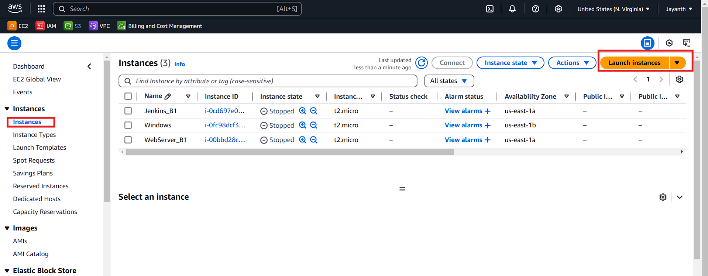  
  
  
  
  
Enter a name for your server.

Choose Amazon Linux as the operating system.  
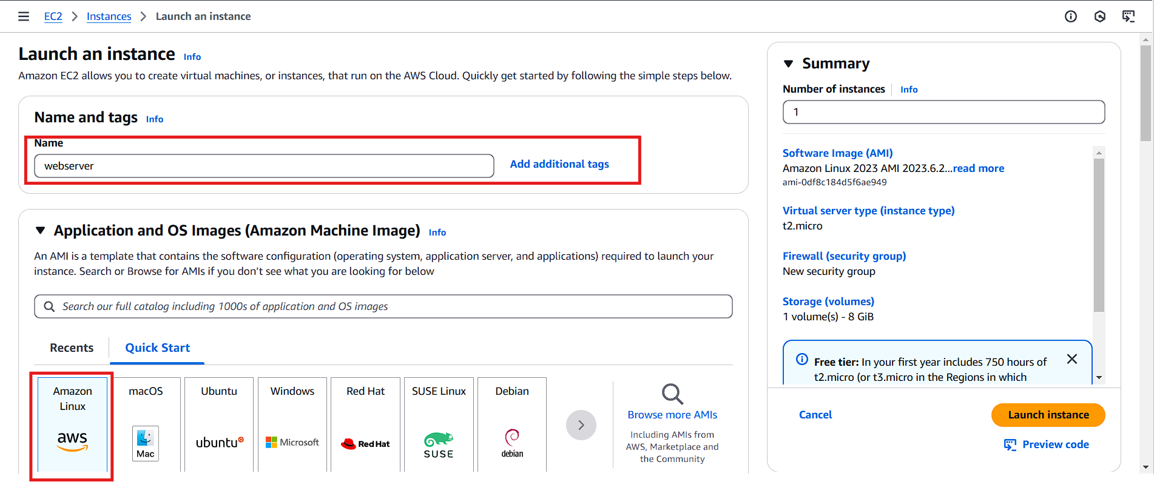  
  
  
  
  
  
  
  
Select **Amazon Linux 2 AMI** and choose the **t2.micro** instance type.  
  
  
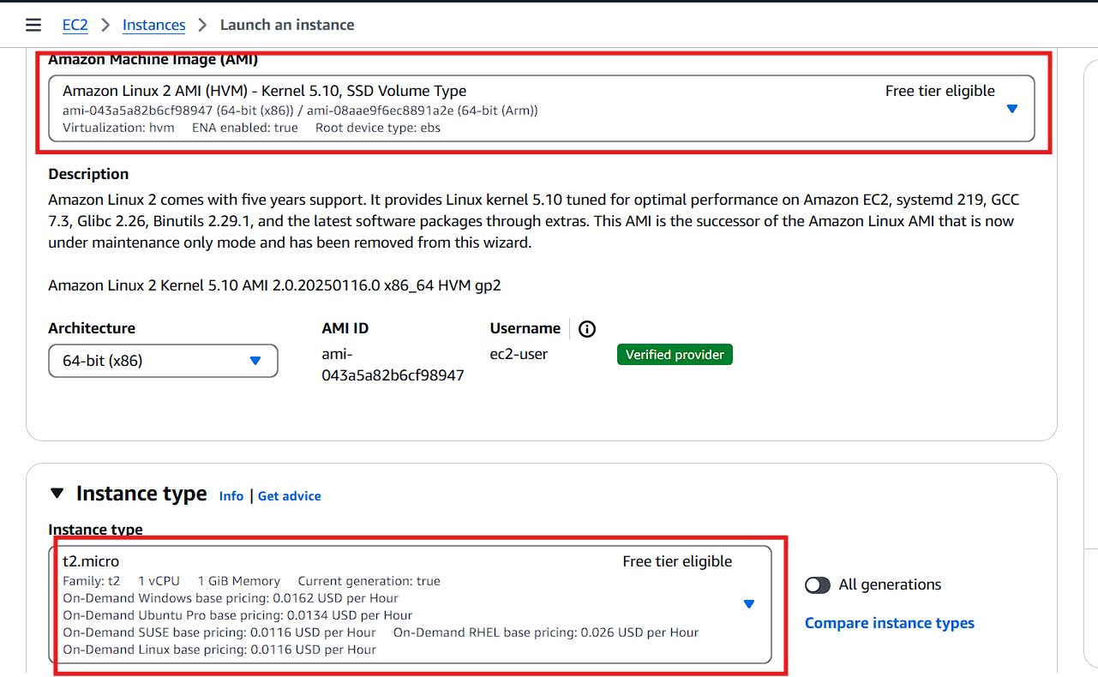  
  
  
  
Click on Create new key pair.

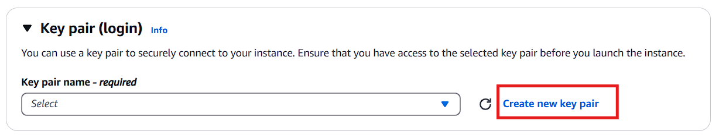  
  
  
  
  
  
  
  
  
  
  
  
  
Provide a name for the key pair and click Create Key Pair.

The key pair will be downloaded automatically; store it in a secure location, as it will be used to log in to the instance.  
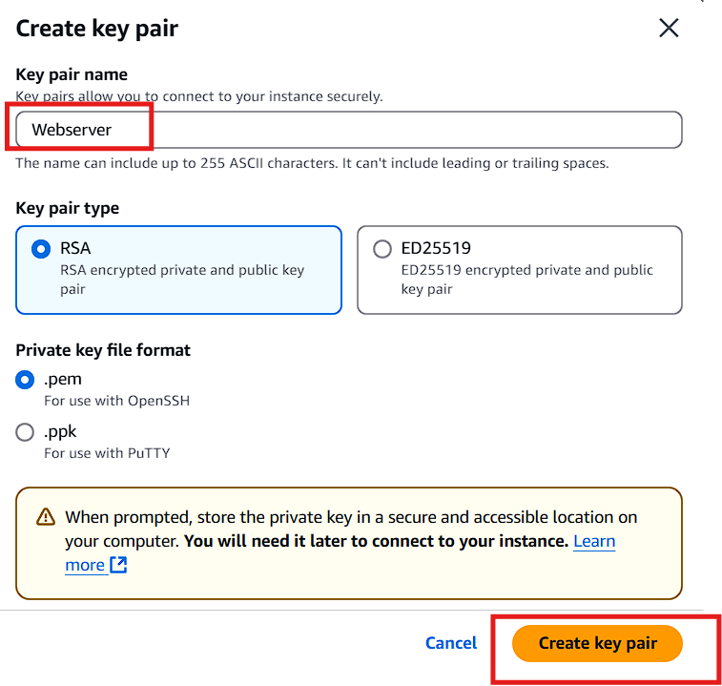  
  
  
  
  
  
  
  
  
  
  
  
  
Click on Create security group.

Ensure you select all the necessary options as shown.

Finally, click Launch Instance.  
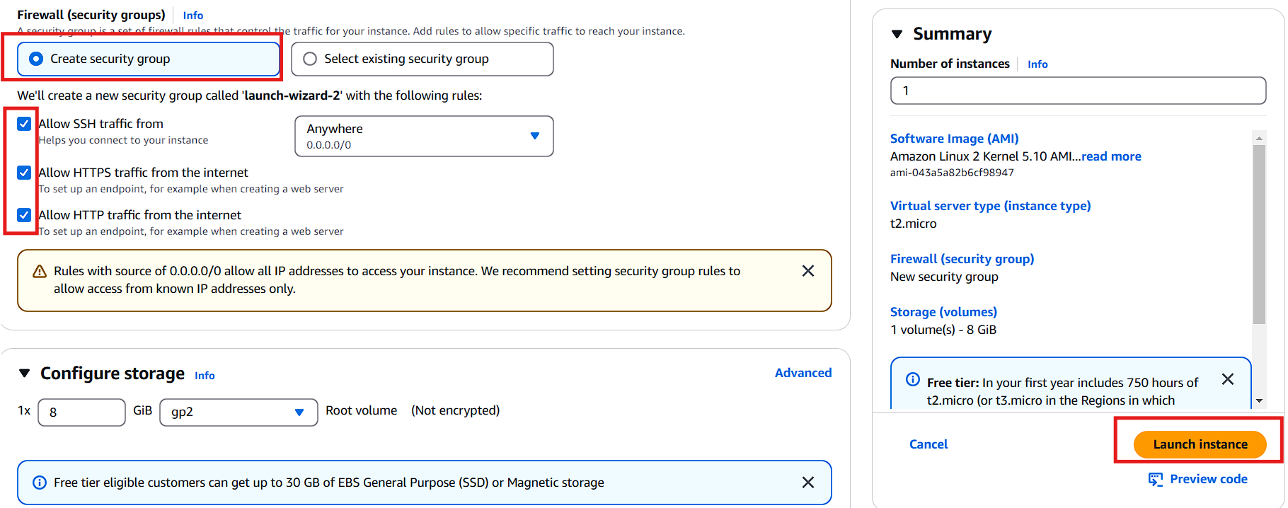  
  
  
  
  
After the instance is launched, select it and click Connect.

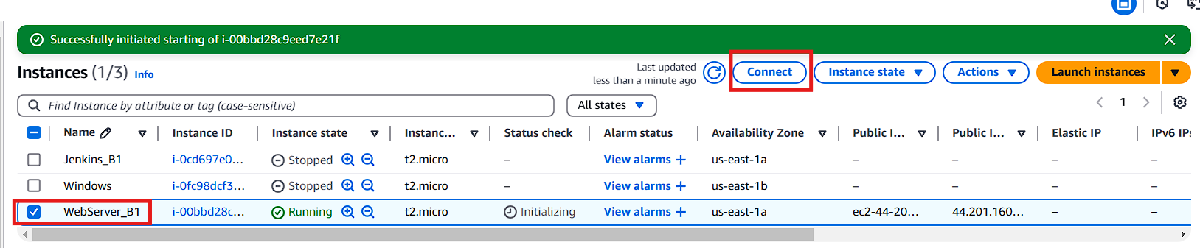  
  
  
  
  
  
  
  
  
  
  
  
  
  
  
  
Copy the highlighted command provided for read-only permissions setup.  
  
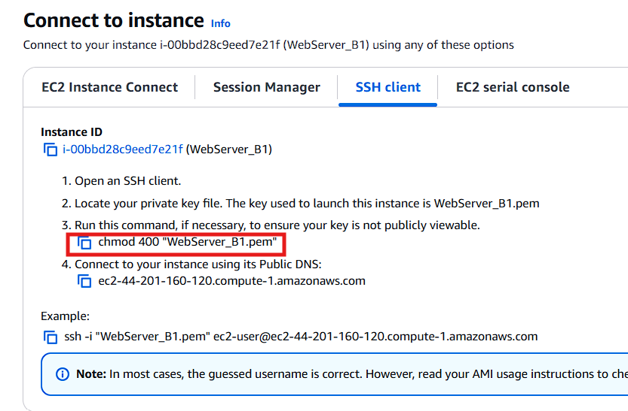  
  
  
  
Navigate to the path where your key pair is stored.

Right-click on the key pair file and select Git Bash.

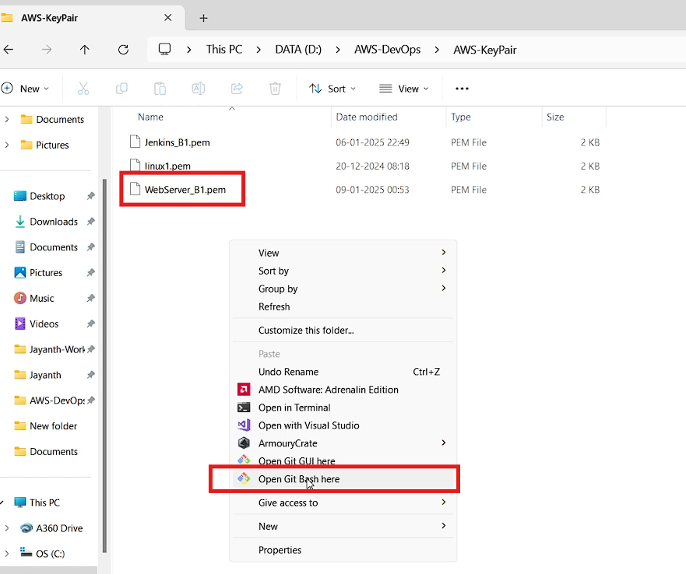  
Paste the copied command into Git Bash and press Enter.  
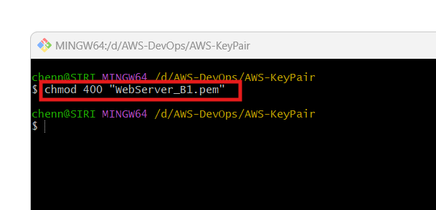  
  
  
  
  
Copy the next command provided, paste it into Git Bash, and press Enter.

Type yes when prompted to proceed to the web server instance.  
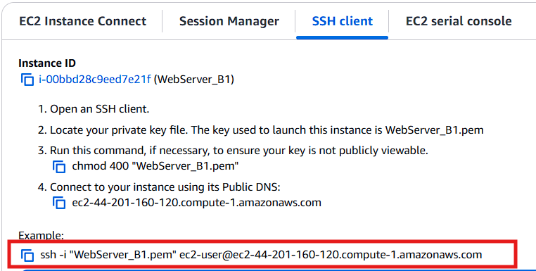  
  
Execute the following commands one by one:  
  
sudo su -

yum install httpd -y

systemctl start httpd

systemctl status httpd

systemctl enable httpd  
  
Run these commands to install and start the firewall:  
yum install firewalld -y

systemctl start firewalld

systemctl enable firewalld  
  
Navigate to the appropriate path and create an index.html file.

Add some content to the file, then press Ctrl+D to save.  
  
  
  
  
  
  
  
Use the following commands to open TCP port 80 on the server:

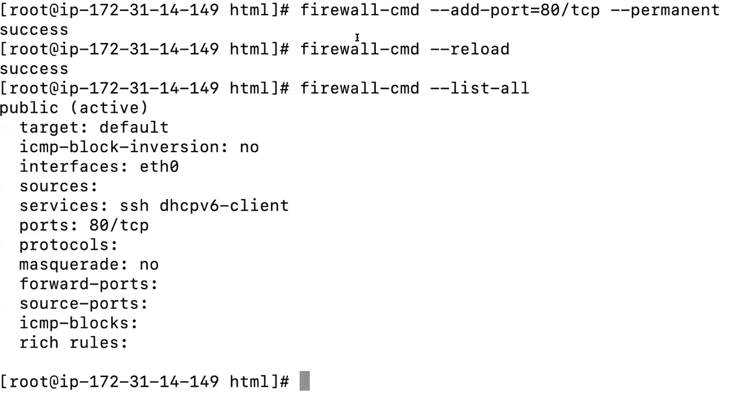  
  
  
  
  
  
  
  
  
Copy the public IP address of the web server.

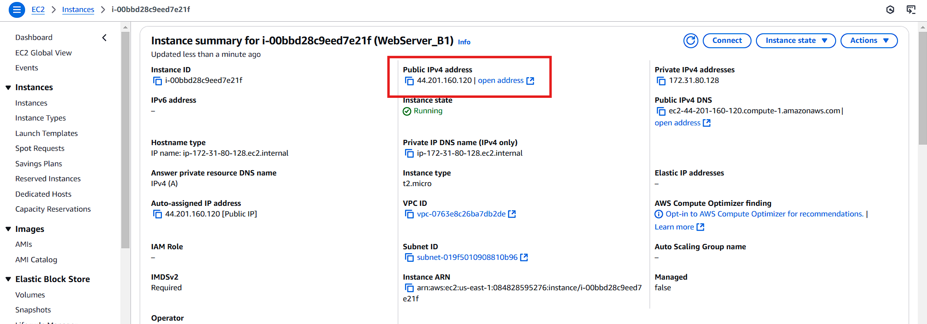  
  
  
  
  
Enter the IP address in your browser as follows: http://(public IP)/index.html.

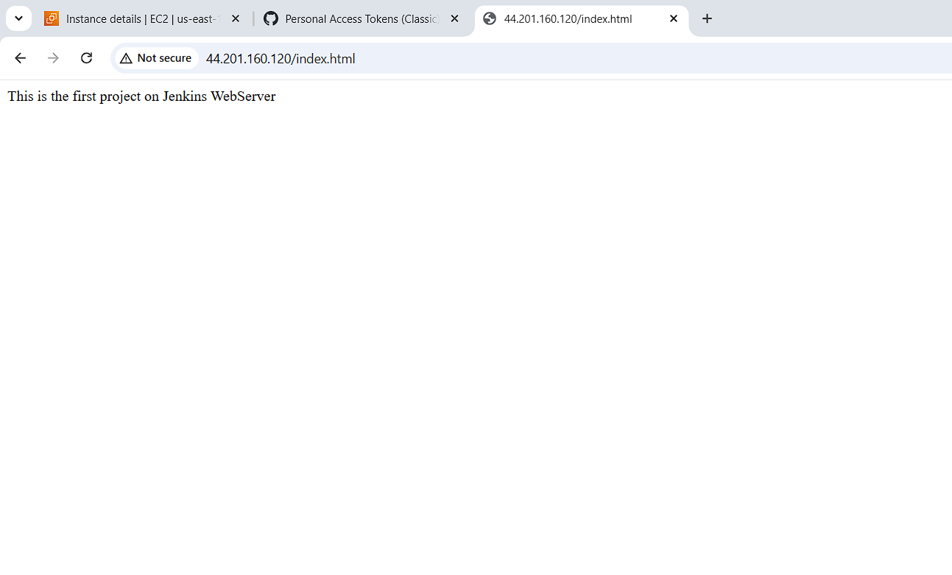  
  
**If the page loads successfully, the web server, firewall, and port configurations are correctly set up, and your web server is functioning.**